**PSYC5605: Unit 5**

**Using hierarchical multiple regression to test for predictive validity**

In session 2, you were shown how to perform a simultaneous multiple regression and you are now ready to have a go at a hierarchical multiple regression. A hierarchical multiple regression allows the predictor variables to be entered into the regression in steps that have been decided by the researcher based on research and expectations (rather than entering them all same at the same time as we did using the simultaneous method).

Using this method, you can build several regression models by adding variables to a previous model in steps (later models always include smaller models in previous steps). In many cases, this allows us to determine whether newly added variables show a significant improvement in *R2* (the proportion of variance explained in the model). Hierarchical regression can be used to answer many different research questions, including assessing predictive validity.

Predictive validity involves testing whether a scale measuring a psychological construct (e.g., impulsiveness, extraversion, self-esteem) predicts a future outcome (e.g. suicidal tendencies, job performance, burnout).

**Example: Assessing the predictive validity of the hope scale in predicting general health**

The following example shows you how to perform a hierarchical multiple regression to assess the predictive validity of a scale. Please use the data set for hierarchical regression, which can be found in both the assessment folder and the week 3 workshop folder on Bb.

This data set includes scale measures of flourishing, hope and life satisfaction which were measured at the start of a one year masters course and a scale measure of general health which was taken at the end of the year. With this particular measure of general health a high score indicates more general health problems. Based on previous research, we would expect those who are more satisfied with life and those who are more hopeful to have fewer general health problems.

To demonstrate the predictive validity of the hope scale we will run a multiple hierarchical regression, including both hope and life satisfaction in step 1 (block 1) and flourishing in step 2 (block 2). **This will allow us to see if the scale hope predicts scores in general health and whether or not the flourishing scale improves model 1 (hope and life satisfaction).** To do this we will be entering hope and life satisfaction into the first block (model 1) and then adding flourishing into the second block (model 2).

**Check your understanding**

What will be the outcome variable? ­­­­­________________________

What will be the predictor variables? 1. ________________________

2. ________________________

3. ________________________

Which predictors will be included in step 1? 1. ________________________

2. ________________________

Which predictor will be added in step 2? ________________________

**A quick recap on assumption testing**

Before we look at how to run the analysis, it is a good idea to remind ourselves about the assumptions for multiple regression. When analysing your own data, do not be surprised if one or more assumptions are violated. This is not uncommon when working with a real data set. However, do not worry. If your data does not meet certain assumptions, there is often a solution. For the purposes of this example and the assignment, it is enough to simply report that the assumption has not been met and to acknowledge that this means any conclusions should be treated with caution. First, let's look at the 8 assumptions.

1. Your **outcome variable** should be measured on a continuous scale (i.e., it is either an **interval** or **ratio** variable).
2. You must have **two or more continuous or categorical predictor variables.**
3. You should have **independence of observations** (i.e., **independence of residuals**), which you can easily check using the Durbin-Watson statistic that forms part of the SPSS output. A value of around 2 is fine.
4. There needs to be a **linear relationship** between (a) the dependent variable and **each** of your independent variables, and (b) the dependent variable and the independent variables **collectively**. **Scatterplots** and **partial regression plots** can be created using SPSS, and these plots can be visually checked for linearity.
5. Your data needs to show **homoscedasticity**, which is where the variances along the line of best fit remain similar as you move along the line.
6. Your data must not show **multicollinearity**, which occurs when you have two or more independent variables that are highly correlated with each other. This leads to problems with understanding which independent variable contributes to the variance explained in the dependent variable, as well as technical issues in calculating a multiple regression model. SPSS calculates correlation coefficients and Tolerance/VIF values that can be used to determine whether your data meets or violates this assumption.
7. There should be **no significant outliers**. These represent observations in your data set that are in some way unusual when you wish to perform a multiple regression analysis and may have an impact on the regression line. Outliers can reduce the predictive accuracy of your results as well as the statistical significance. Again SPSS can detect possible outliers.
8. Finally, you need to check that the **residuals (errors)** are **approximately normally distributed**. To check this assumption, check the histogram and a Normal P-P or Normal Q-Q Plots of the studentized residuals.

**Running the hierarchical regression**

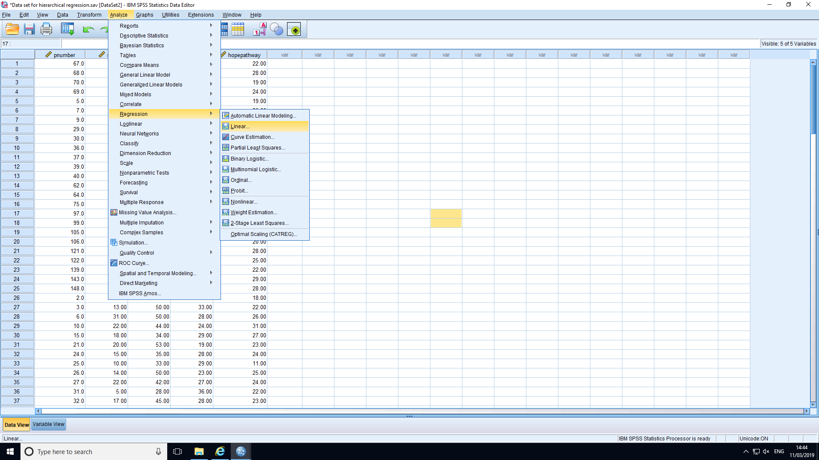

1. Start by selecting ANALYZE, REGRESSION and then LINEAR from the menu.

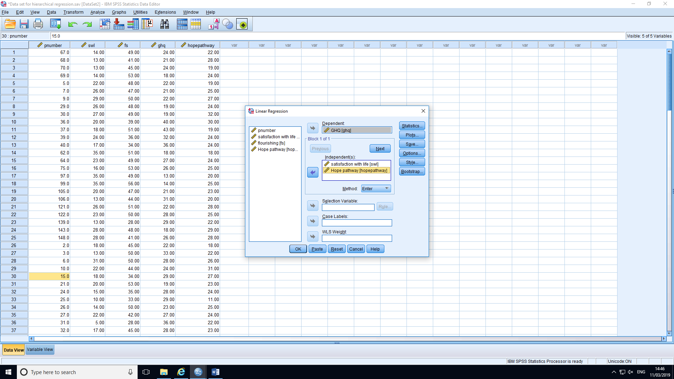

2. The main dialogue box should now appear

3. You now need to enter the outcome (dependent box) and predictor variables (independent(s) box) for block 1.

4. You will see that there is a little drop down menu for the method. Leave this set to the default value (“Enter”) for now.

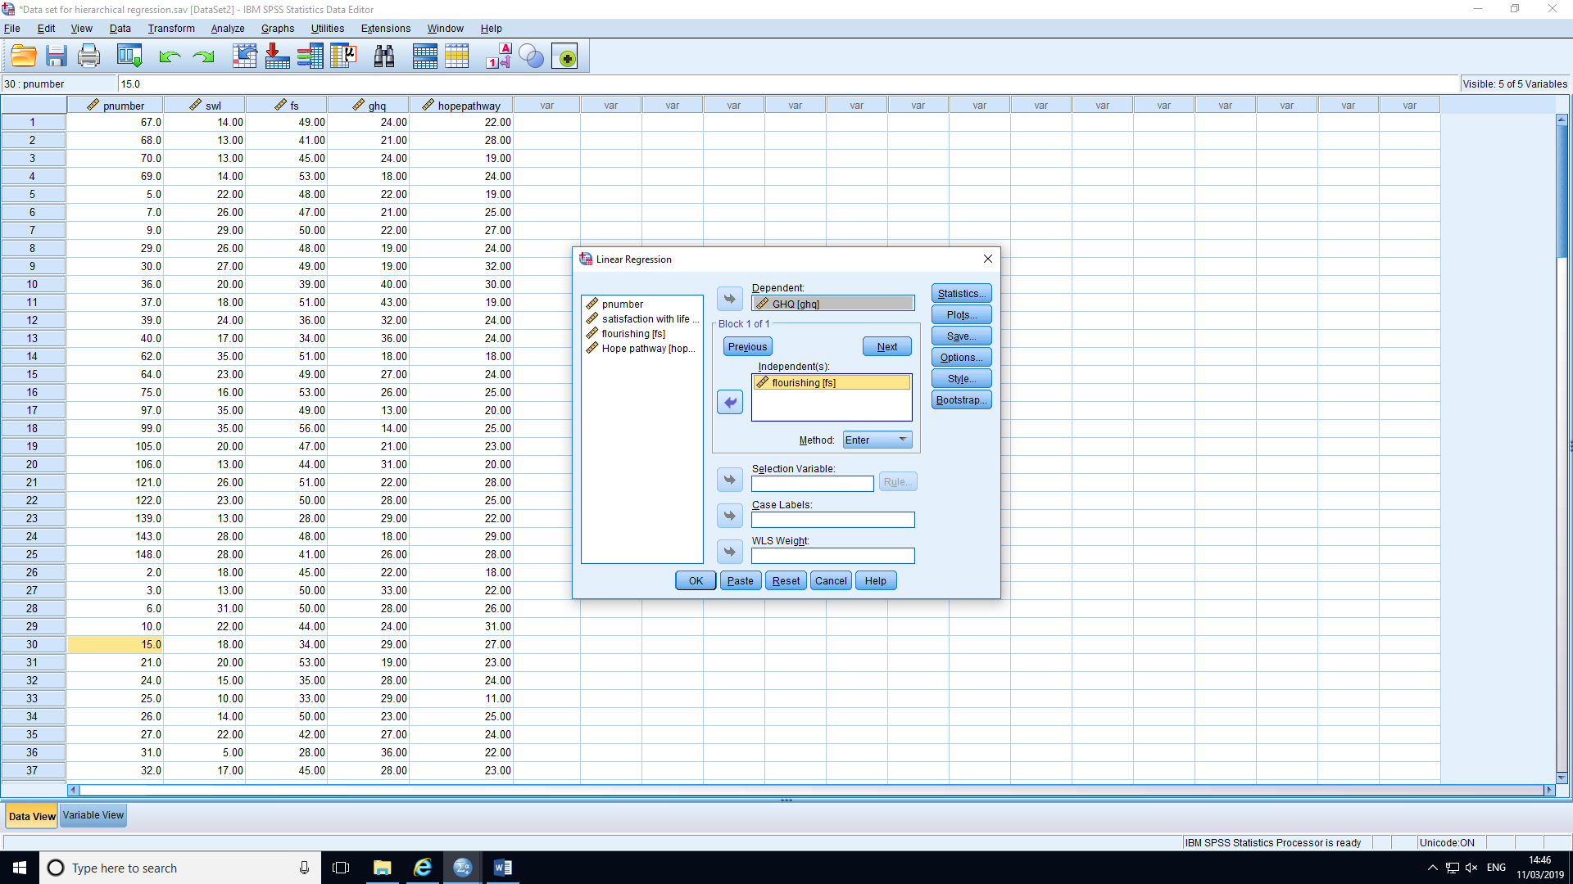

5. We now click on Next to enter the second block (model 2).

6. Enter only flourishing into the independent(s) box.

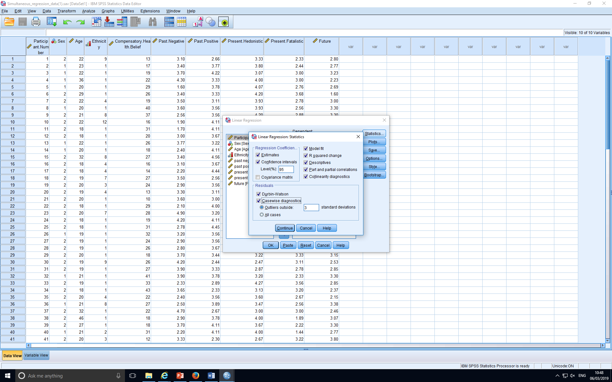

7. Next, click on the “Statistics” button to view this dialog box and tick the appropriate boxes.

8. Click on Continue.

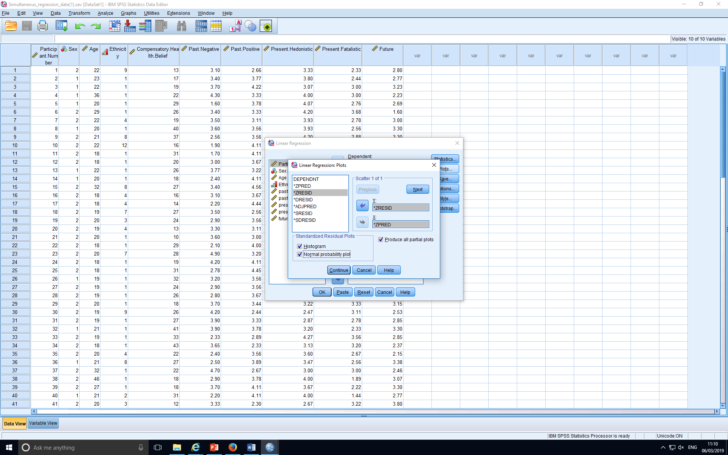

9. Next, click on PLOTS. In the dialogue box, select options as below. Move ZRESID to Y axis and ZPRED to X axis. Then select plots as illustrated. This provides a scatterplot to check homogeneity of error variances.

10.Now click on OK to run your analysis

**Now, we can take a look at the output that SPSS gives you when you run the analysis.**

|  |
| --- |
|  |

**Interpreting the SPSS outcome**

|  |  |  |  |
| --- | --- | --- | --- |
| **Descriptive Statistics** | | | |
|  | Mean | Std. Deviation | N |
| GHQ | 24.9790 | 6.37056 | 143 |
| satisfaction with life | 22.5804 | 6.58360 | 143 |
| Hope | 23.6573 | 7.94799 | 143 |
| Flourishing | 43.6014 | 7.50224 | 143 |

1. The first box gives us the usual descriptive statistics for each of the measurements.

2. This second box shows us correlations between the variables. If any correlations are above 0.8 or 0.9 this may suggest multicollinearity. Here we can see that Hope and Satisfaction with life are highly correlated (*r* = .94) so this raises some concerns about multicollinearity.

|  |  |  |  |  |  |
| --- | --- | --- | --- | --- | --- |
| **Correlations** | | | | | |
|  | | GHQ | satisfaction with life | Hope | flourishing |
| Pearson Correlation | GHQ | 1.000 | -.508 | -.489 | -.563 |
| satisfaction with life | -.508 | 1.000 | .935 | .496 |
| Hope | -.489 | .935 | 1.000 | .431 |
| Flourishing | -.563 | .496 | .431 | 1.000 |
| Sig. (1-tailed) | GHQ | . | .000 | .000 | .000 |
| satisfaction with life | .000 | . | .000 | .000 |
| Hope | .000 | .000 | . | .000 |
| Flourishing | .000 | .000 | .000 | . |
| N | GHQ | 143 | 143 | 143 | 143 |
| satisfaction with life | 143 | 143 | 143 | 143 |
| Hope | 143 | 143 | 143 | 143 |
| Flourishing | 143 | 143 | 143 | 143 |

3. This box shows us which variables were entered at each step. You can see that Hope and Satisfaction were added in block 1 and make up model 1. Flourishing, however, was entered in block 2 and it was added to predictors of block 1 (Hope and Satisfaction) to form model 2.

|  |  |  |  |
| --- | --- | --- | --- |
| **Variables Entered/Removeda** | | | |
| Model | Variables Entered | Variables Removed | Method |
| 1 | Hope, satisfaction with lifeb | . | Enter |
| 2 | flourishingb | . | Enter |
| a. Dependent Variable: GHQ | | | |
| b. All requested variables entered. | | | |

4. The model summary box tells us how good the model is for predicting General health problem scores and some assumption testing results.

The most important bits to take from this box are as follows:

1. *R* tells us the “goodness of fit *R2*” of our regression models (how well our model explains the data), a large R means a good fit with the observed data.
   * Therefore, we can see that the fit of both models is fairly good using Cohen’s classification of size (*R* = .51 and *R* = .63)
2. *R2* gives us the proportion of the variance explained by the models. We can multiply the coefficient of determination (*R2*) by 100 to get the percentage of explained variance. Model 1 explains 26% of the variance in General health. Model 2 explains 39%.
3. Adjusted *R2* gives us the adjusted *R2* adjusting the number of predictors. In addition, this needs to be quite similar to the *R2* figure in order that the regression model is generalisable to the population.
   * Therefore, we can see the models are generalisable as adjusted *R2* is very similar to *R2* for both models
4. The Durbin Watson statistic tells us whether the data have met the assumption of independent errors. Values around 2 are fine. Our data have a DW of 1.72, so it is fine.

|  |  |  |  |  |  |  |  |  |  |  |  |
| --- | --- | --- | --- | --- | --- | --- | --- | --- | --- | --- | --- |
| **Model Summaryc** | | | | | | | | | | | |
| Model | R | R Square | Adjusted R Square | Std. Error of the Estimate | Change Statistics | | | | | Durbin-Watson |
| R Square Change | F Change | df1 | df2 | Sig. F Change |
| 1 | .509a | .259 | .249 | 5.52116 | .259 | 24.526 | 2 | 140 | .000 |  |
| 2 | .627b | .393 | .379 | 5.01826 | .133 | 30.466 | 1 | 139 | .000 | 1.724 |
| a. Predictors: (Constant), Hope, satisfaction with life | | | | | | | | | | | |
| b. Predictors: (Constant), Hope, satisfaction with life, flourishing | | | | | | | | | | | |
| c. Dependent Variable: GHQ | | | | | | | | | | | |

5. The ANOVA box tells us whether our models are significantly better than the mean (intercept or “constant”) at predicting scores on our outcome variable.

* + Both of our models are significant and should be reported in the same manner as for ANOVA.
  + Model 1: *F*(2, 140) = 24.53, *p* < .001.
  + Model 2: *F*(3, 139) = 29.95, *p* < .001.

|  |  |  |  |  |  |  |
| --- | --- | --- | --- | --- | --- | --- |
| **ANOVAa** | | | | | | |
| Model | | Sum of Squares | Df | Mean Square | F | Sig. |
| 1 | Regression | 1495.290 | 2 | 747.645 | 24.526 | .000b |
| Residual | 4267.647 | 140 | 30.483 |  |  |
| Total | 5762.937 | 142 |  |  |  |
| 2 | Regression | 2262.510 | 3 | 754.170 | 29.948 | .000c |
| Residual | 3500.427 | 139 | 25.183 |  |  |
| Total | 5762.937 | 142 |  |  |  |
| a. Dependent Variable: GHQ | | | | | | |
| b. Predictors: (Constant), Hope, satisfaction with life | | | | | | |
| c. Predictors: (Constant), Hope, satisfaction with life, flourishing | | | | | | |

6. The coefficients box is one of the most important as it tells us which predictors are significantly influencing our outcome variables, in which direction, and by how much.

1. The unstandardised Beta box tells us the contribution of each predictor to each model when other predictors are held constant (akin to partial correlations). The standardised beta tells us that as the predictor changes by 1 *SD*, how many *SD*’s the outcome variable will change. The *t*-test and significance level (*p* value) will tell us whether the predictor is significantly contributing to the model.

1. The 95% Confidence Intervals (95% CIs) tell us the boundaries (Lower and Upper bounds) within which the beta values of 95% of the sample would fall. Non-significant predictors usually have confidence intervals that include the zero, indicating that in some samples the predictor has a positive relationship with the outcome, in other samples it has a negative relationship with the outcome. You can see that this is the case for all but one of our variables.

Can you identify which variable this is and explain why it is different to the others?

________________________________________________________________________________________________________________________________________________________________________________________________________________________________________________________________________________

1. In model 1: neither Satisfaction with life nor Hope significantly contributed to the model. Satisfaction with life had a negative relationship with General health problems. Therefore, as Satisfaction with life increases General health problems will decrease (*Beta* = – 0.38, *SD*Beta = 0.20). With 1 *SD* increase in Satisfaction with life, General health problems will decrease by 0.40 *SD* (β = – .40). Hope also has a negative relationship with general health (*Beta* = – 0.10, *SD*Beta = 0.16). Therefore, as hope increases by 1 *SD*, General health will decrease by 0.12 *SD* (β = – .12).
2. In model 2: neither Satisfaction with life nor Hope significantly contributes to the model. HoweAs in model 1, Satisfaction with life has a negative relationship with General health problems. Therefore, as Satisfaction with life increases General health problems will decrease. With 1 *SD* increase in Satisfaction with life, General health problems will decrease by 0.09 *SD* (β = – .09). Hope also has a negative relationship with general health problems (*Beta* = – 0.18, *SD*Beta = 0.15). Therefore, as hope increases by 1 *SD*, General health will decrease by 0.23 *SD*. However, Flourishing did significantly contribute to the model. (*Beta* = – 0.36, *SD*Beta = 0.07, *p* < .001). With 1 *SD* increase in Flourishing, General health will decrease by 0.42 *SD* (β = – .42, 95% CI [– .49, – .23]).
3. VIF tells us whether there is collinearity in the data. It needs to be around 1–3. Any VIF values greater than 10 will be a cause for concern and the predictor may need removing and the analysis re-run due to collinearity.

|  |  |  |  |  |  |  |  |  |  |  |  |  |  |  |
| --- | --- | --- | --- | --- | --- | --- | --- | --- | --- | --- | --- | --- | --- | --- |
| **Coefficientsa** | | | | | | | | | | | | | | |
| Model | | Unstandardized Coefficients | | Standardized Coefficients | T | Sig. | 95.0% Confidence Interval for B | | Correlations | | | Collinearity Statistics | | |
| B | Std. Error | Beta | Lower Bound | Upper Bound | Zero-order | Partial | Part | Tolerance | VIF |
| 1 | (Constant) | 35.898 | 1.681 |  | 21.349 | .000 | 32.573 | 39.222 |  |  |  |  |  |
| satisfaction with life | -.384 | .198 | -.397 | -1.940 | .054 | -.775 | .007 | -.508 | -.162 | -.141 | .127 | 7.904 |
| Hope | -.095 | .164 | -.119 | -.580 | .563 | -.419 | .229 | -.489 | -.049 | -.042 | .127 | 7.904 |
| 2 | (Constant) | 46.805 | 2.498 |  | 18.735 | .000 | 41.866 | 51.745 |  |  |  |  |  |
| satisfaction with life | -.083 | .188 | -.086 | -.444 | .658 | -.455 | .288 | -.508 | -.038 | -.029 | .116 | 8.629 |
| Hope | -.182 | .150 | -.227 | -1.214 | .227 | -.478 | .114 | -.489 | -.102 | -.080 | .125 | 7.992 |
| Flourishing | -.359 | .065 | -.422 | -5.520 | .000 | -.487 | -.230 | -.563 | -.424 | -.365 | .746 | 1.340 |
| a. Dependent Variable: GHQ | | | | | | | | | | | | | | |

7. The Casewise diagnostics box tells us whether there are any cases that might be unduly affecting our model (outliers). It identifies any cases that have a residual outside of 3 standard deviations. It shows that case 32 has a standardised residual of 3.84. As this value is greater than 3, it could potentially influence our results. Therefore, we could remove the data from this participant and re-run the analysis. As it is not far above 3, it may not be necessary, however, huge outliers must be removed in order to improve the accuracy of the models.

|  |  |  |  |  |
| --- | --- | --- | --- | --- |
| **Casewise Diagnosticsa** | | | | |
| Case Number | Std. Residual | GHQ | Predicted Value | Residual |
| 32 | 3.839 | 43.00 | 23.7360 | 19.26396 |
| a. Dependent Variable: GHQ | | | | |

8. This chart shows us the dispersion of residuals. This plot can be used to test the assumption of homoscedasticity (i.e., residuals at each level of the predictor should have the same variances). The assumption is met when the dots cluster around 0. Most of our dots are between -2 and +2 and seem to be evenly distributed around 0 therefore the assumption of homoscedasticity has been met. This chart would not be needed in the actual write up, however mention of checking for homoscedasticity would be necessary.

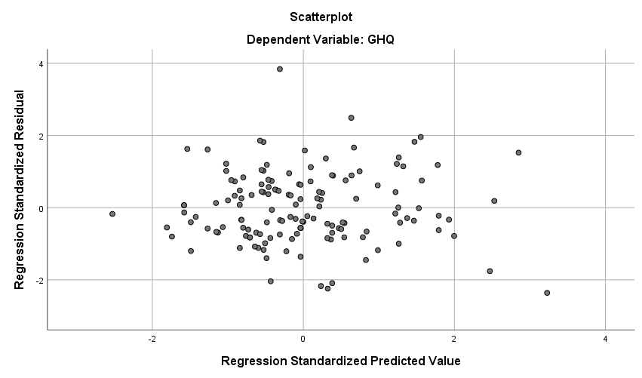

9. Finally, you need to check that the **residuals (errors)** are **approximately normally distributed**. To check this assumption, check the histogram and a Normal P-P and Q-Q Plots. On the below two graphs you can see that data roughly fits the normal curve and the best fit line.

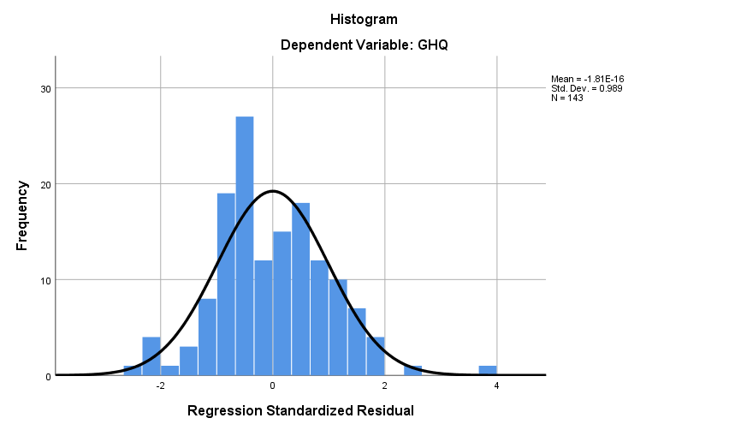

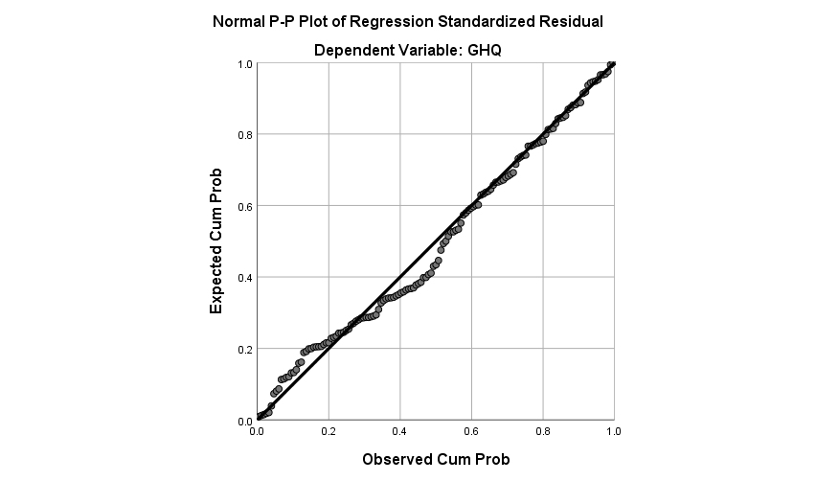

**Reporting the results**

To examine the predictive validity of the Hope scale on General health, a two-step, hierarchical multiple regression analysis was conducted. First, we included the scales Satisfaction of life and Hope in the first block (model 1) as theory indicates that they should be important predictors. Second, we added—in a more exploratory way—Flourishing scale in the second block (model 2).

Our outcome variable (General health scale) and predictors (Satisfaction of life, Hope, and Flourishing scales) were interval/ratio continuous scales, the observations were independent, the assumptions of homoscedasticity (ZRES and ZPRED values are randomly distributed within 2 *SD* boundaries) and multicollinearity (VIF < 10) were met, errors were assumed to be independent (Durbin-Watson = 1.72), and the outcome and predictors were related linearly. However, Hope and Satisfaction with life were highly correlated (*r* = .94), raising some concerns about collinearity between these two predictors. Likewise, the data seems to be fairly normally distributed but one outlier has been detected (case 32).

The hierarchical multiple regression showed that in model 1, although it accounted for the 26% of the variation in General health, Satisfaction with life and Hope scales did not contribute significantly to the regression model, β = – .40, 95% CI[– .78, .01], *p* = .054, and β = – .12, 95% CI[– .42, .23], *p* = .563, respectively. Introducing Flourishing scale in model 2 explained an additional 13% variance, *F*change(1, 139) = 30.47, *p* < .001. In model 2, Flourishing was the only predictor contributing significantly to the model, β = – .42, 95% CI[– .49, – .23], *p* < .001 (Table 1). In sum, the scale Hope lacked predictive validity for scores of General health.

|  |  |  |  |  |  |  |  |  |
| --- | --- | --- | --- | --- | --- | --- | --- | --- |
| Table 1  *Summary of Hierarchical Regression Analysis for Variables Predicting General Health* | | | | | | | | |
|  | Model 1 | | | | Model 2 | | | |
| Variable | *B* | *SE*(*B*) | *β* | 95%CI | *B* | *SE*(*B*) | *β* | 95%CI |
| Satisfaction | – 0.38 | 0.20 | – .40 | [– .78, .01] | – 0.08 | 0.19 | – 0.09 | [– .46, .29] |
| Hope | – 0.10 | 0.16 | – .12 | [– .42, .23] | – 0.18 | 0.15 | – 0.23 | [– .48, .11] |
| Flourishing |  |  |  |  | – 0.36 | 0.07 | – 0.42*** | [– .49, – .23] |
| *Adjusted R*2 | .25 |  |  |  | .38 |  |  |  |
| Note. *N* = 143. * *p* < .05. ** *p* < .01. *** *p* < .001. | | | | | | | | |

**For assignment 3, a hierarchical multiple regression will be used to assess the predictive validity of the scale Impulse on Dispositional Envy**

The data set used for Assignment 3 consists of data that was collected at two points in time. At the first time point, participants completed a questionnaire pack, which consisted of providing some demographic details and completing the scales Impulse and Rosenberg’s Self-esteem. At the second time point, Dispositional envy was measured.

Your task is to assess the predictive validity of the scales Impulse and Rosenberg’s Self-esteem on Dispositional Envy first. You will also explore whether age predicts Dispositional envy.

**For Assignment 3, you will need to complete the following:**

1. You will need to run a 2 step hierarchical regression and estimate two multiple regression models.
2. In **step one (model 1),** you will include two predictors: Impulse (first predictor) and Self-esteem (second predictor). Dispositional envy will be your outcome variable. Model 1 will tell you whether impulse and self-esteem predict dispositional envy. This will be model 1.
3. In a **step 2** (model 2), you will add a new predictor (Age) to explore if it will provide more explanatory power than the initial model. You will be looking at whether model 2 (which includes Impulse, Self-esteem and Age) better predicts scores for Dispositional envy.
4. You will need to decide which model explains significantly more variance and whether the Impulse scale has predictive validity on Dispositional envy.

**Reporting your results**

You will need to report the results of the hierarchical regression in box number 6 (Predictive validity) on the poster. See how to report this section by reviewing the example used in class with the General health scale, and the predictors Satisfaction, Hope, and Flourishing. The key elements that you need to include are three paragraphs and one table:

1. Paragraph 1: Describe the outcome, predictors, and the models.
2. Paragraph 2: Assumption testing (1–3 sentences maximum).
3. Paragraph 3: Report the key findings of model 1 (the explained variance of the model and the contribution of each predictor to the model), the change in *R*2 due to the inclusion of model 2 (*F* change and *R*2 change), and the key findings of model 2 (the explained variance of model 2 and the contribution of each predictor to the model). Remember to refer to Table 1 in this third paragraph.
4. Complete Table 1 showing the main statistics of models 1 and 2.